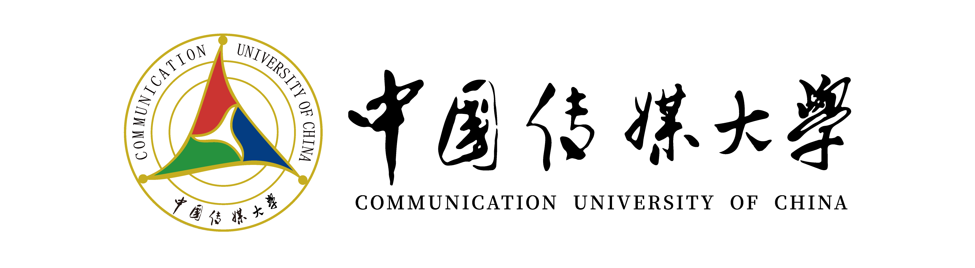

Pre-graduation Certificate

This is to certify that 姓名, male/female, is enrolled as an undergraduate student in School of 学院, for four/two years fulltime bachelor program. His/Her student ID is 学号. The student's enrollment status remains unchanged as of this date. 姓名 is expected to graduate in 预计毕业时间.

Undergraduate School
Communication University of China
20 - -

